ROH-DICE Association Analysis Report

Dataset:
SOURCE: This project uses the HapMap 3 dataset provided Marees et al. GWAS tutorial. https://github.com/MareesAT/GWA_tutorial
This dataset is part of a GWAS analysis tutorial which included script including quality control, population stratification, and association analysis. The population stratification step is skipped because the main focus of this project was on ROH association analysis.
- 109 individuals with a binary phenotype: 54 cases and 55 controls.
- The starting genotype dataset contained 1,073,226 variants.
- Before Beagle processing, 129 non-standard I/D variants were removed.
- 1,073,097 variants in the phased dataset is used for ROH analysis.
- ROH-DICE was run with W=10 and L=100 sites in its default mode.

Post-processing QC:
- The raw ROH-DICE output contained 3,953 cluster records.
- After a 1% within-cluster heterozygosity filter, it reduced from 60,830 to 46,563
- After reapplying W>=10, 2,206 candidate ROH clusters remained for association testing.

2. Cluster-level association
For each of the 2,206 clusters, with (0) case/ (1) control status. A Pearson chi-square test and Odds ratios were calculated for each cluster member.
Association metric | Result
Clusters tested | 2,206
P < 0.05 | 160
P < 0.01 | 39
P < 0.001 | 5
FDR < 0.05 | 0
FDR < 0.10 | 0
Bonferroni threshold | 2.27 x 10^-5
Bonferroni significant | 0

- Overall, no ROH cluster remained statistically significant after multiple-testing correction. The result is plotted on the below manhatan plot figure.
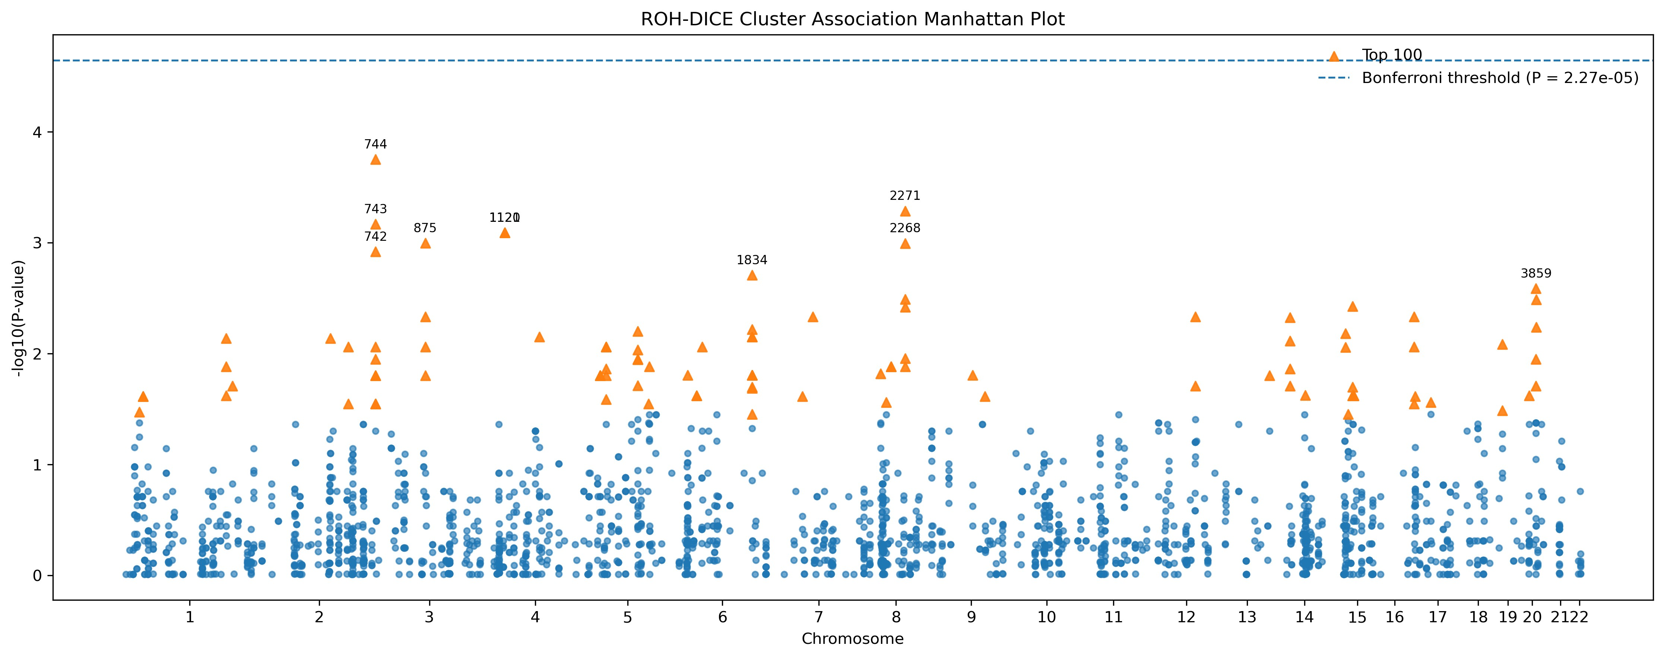

3. Top nominal associations
Although we did not find any statistically significant association after multiple testing, we found some top association relationships with very small p-values in certain regions on choromosomes ROH cluster sites.
Cluster | Chr | Position | N | Case | Control | P / FDR
744 | 2 | 219,389,845 | 16 | 1 | 15 | 1.77e-4 / 0.318
2271 | 8 | 92,414,923 | 14 | 13 | 1 | 5.16e-4 / 0.318
743 | 2 | 219,377,619 | 14 | 1 | 13 | 6.77e-4 / 0.318
1120 | 4 | 44,592,621-44,692,440 | 10 | 10 | 0 | 8.12e-4 / 0.318
1121 | 4 | 44,592,621-44,692,589 | 10 | 10 | 0 | 8.12e-4 / 0.318

4. Interpretation and limitations
- The main limitations of this project was are short sample size (N=109) which lead to not finding any statistcally significant result.
- The second one wasa the absence of covariate adjustment including considering Age, sex, and genetic principal components in the chi-square calculation.

The GWAS analysis output:
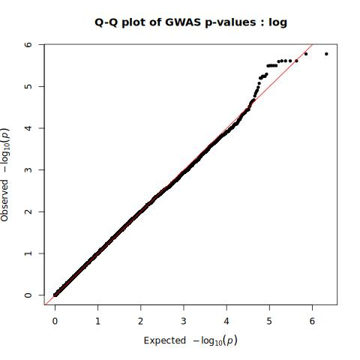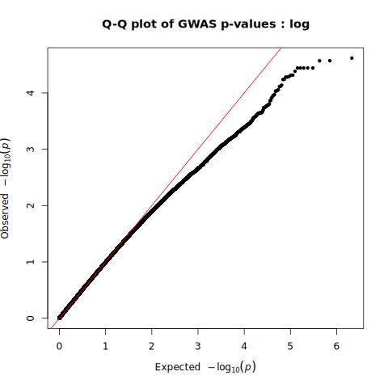
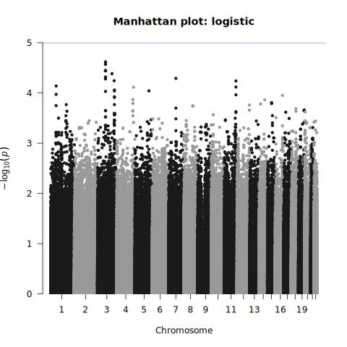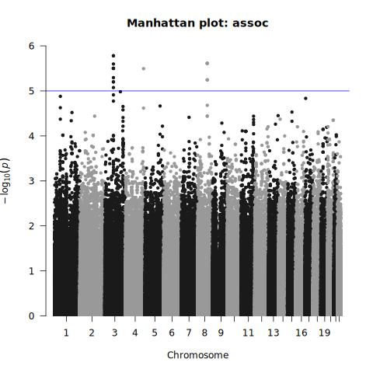

The PRS analysis output:
